Project: Pigeon Pedigree & Management System

Objective: Create a web-based application that allows pigeon breeders to manage their pigeons efficiently. Users can add, view, edit, generate pedigrees, share data, and track race results. The website will feature an intuitive UI and an optimized database structure.

Features and Functionalities:

### **1. Duif Toevoegen (Add Pigeon)**

* Form Fields:
  + Landcode (default setting)
  + Ringnummer (unique identifier)
  + Parent Ring Numbers
  + Naam (Name)
  + Geslacht (Gender: Male/Female)
  + Kleur (Dropdown with predefined colors)
  + Kweker (Breeder: Free text or linked to existing breeders)
  + Discipline (Multiple choices: Vitesse, Halve fond, Grote halve fond, Grote Fond, Fond)
  + Openbaarheid (Visibility setting for public/private access)
* Validation:
  + Check for unique ring numbers and mandatory fields
* Storage:
  + Save data in a relational database

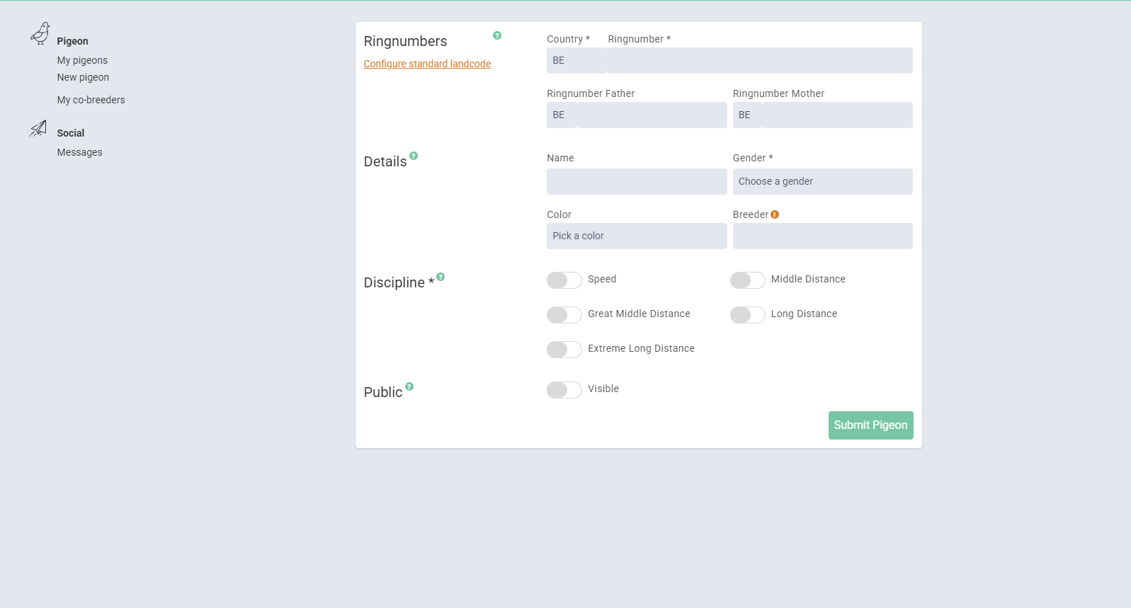

### **2. Mijn Duiven (Pigeon Overview)**

* List View with Search and Sorting:
  + Columns: Name, Co. (Country Code), Ring Number, Father, Mother, Color, Gender, Public, Info
  + Search function for quick lookup
  + Sorting by ring number
* Clickable Rows:
  + Click on a pigeon to view actions:
    - Bekijk Duivenprofiel (View Profile)
    - Bekijk Stamboom (View Pedigree)
    - Bewerk Duif (Edit Pigeon)
    - Verwijder Duif (Delete Pigeon) (Make sure to have a function of a bin where they can readd the pigeon if removed by accident, 30 days max storage)

### 

### 

### 

### 

### 

### 

### 

### **3. Bekijk Duivenprofiel (View Pigeon Profile)**

* Detailed Pigeon Information:
  + Pigeon Photo (Upload Function)
  + Breeder
  + Ring Number
  + Parents (With Links to Their Profiles if Available)
  + Color
  + Discipline
  + Race Results (If Available)
* Actions:
  + View Pedigree
  + Edit Pigeon
  + Change Owner
  + Add Co-Breeder

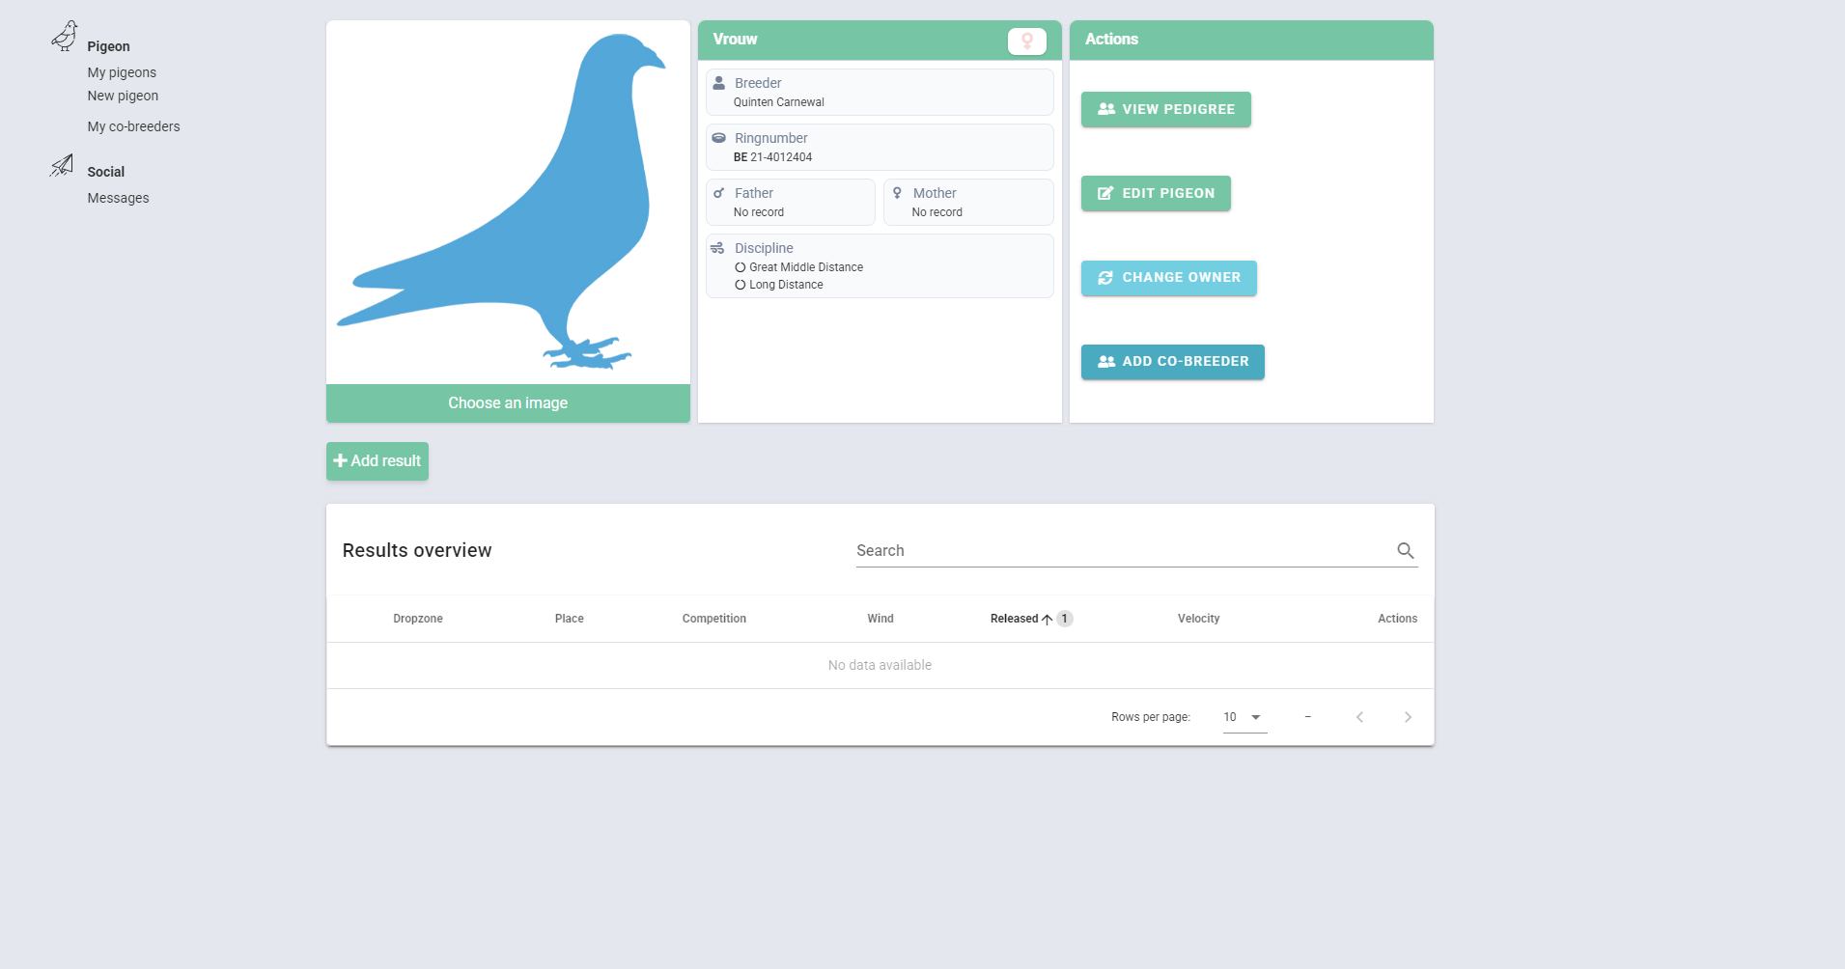

### 

### 

### 

### 

### 

### 

### 

### 

### 

### 

### **4. Stamboom Creator (Pedigree Generator)**

* File Upload & Processing:
  + Users can upload PDF or image files (JPG, PNG, PDF, etc.)
  + OCR (Optical Character Recognition) extracts text from the uploaded file
  + Extracted text is parsed into structured data
* Pedigree Chart Generation:
  + Automatically generates a pedigree chart based on the extracted data
  + The structure matches common pigeon pedigree formats
  + Display includes: Sire, Dam, Grandparents (G. Sire, G. Dam), and Great-Grandparents (G.G. Sire, G.G. Dam) up to 4 generations
* Editable Pedigree:
  + Users can edit all extracted information manually
  + Editable fields include names, breeding details, performance stats, ringnumber etc.
  + Also need to be able to add photo’s to the pedigree and text boxes (Optional option, mostly in the left head corner a photo and left bottom corner their own information)
  + Option to add additional details manually if OCR fails to extract correctly
* Export & Integration:
  + Option to download the final pedigree as a PDF
  + Generate a shareable link for online viewing
  + **Ability to save and manage multiple pedigrees on the platform**

I need to be certain the pedigree generator is dynamic. Once I upload a file (pdf) with the pedigree it has to rebuild the pedigree on the website on the same way and the user should be able to redo all information when uploaded by the possibility of 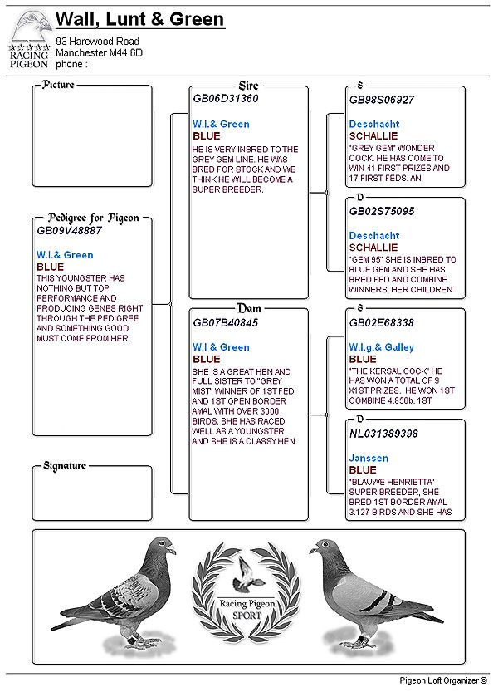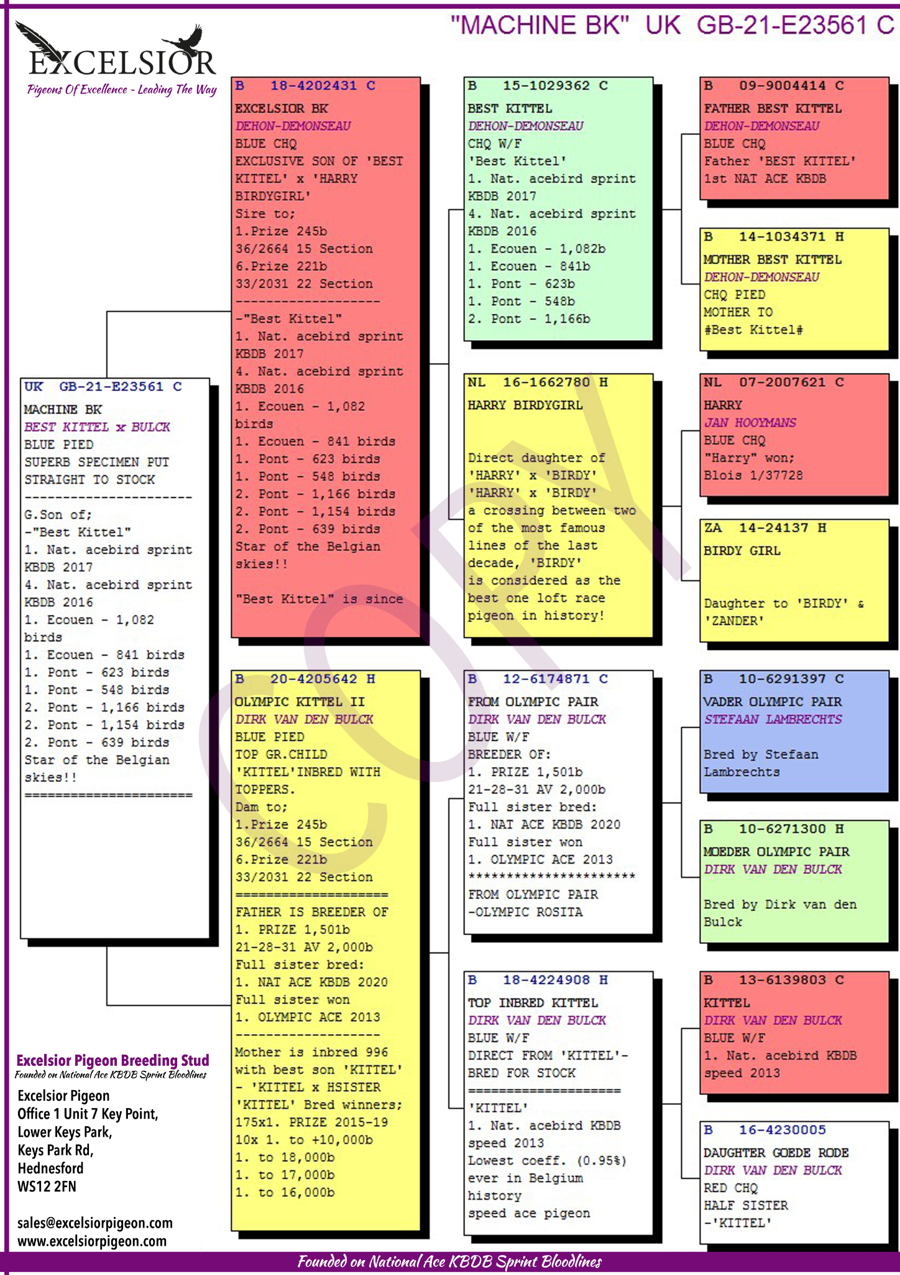editing it himself. (Edit, save buttons)

### 

### 

### 

### 

### 

### 

### 

### 

### 

### **5. Resultatenbeheer (Race Results Management)**

* Add Results per Pigeon:
  + Race Location
  + Placement in Competition
  + Type of Competition
  + Weather Conditions (e.g., wind direction)
  + Release Time
  + Speed
* Results Overview:
  + Searchable and sortable table
  + Filter results per pigeon

### **6. Stamboomoverdracht en Verkoopbeheer (Pedigree Transfer & Sales Management) (SITE WISE)**

* Pedigree File Transfer:
  + Import via linked email
  + Transfer pigeons to another breeder through their email
  + New owner receives a notification and must accept the transfer
  + Upon acceptance, the pigeon is added to the new owner's list and removed from the seller's list
  + If rejected, the pigeon remains with the original owner
* Sold Pigeons Overview:
  + View all sold pigeons, including:
    - Pigeon Name
    - Ring Number
    - New Owner (Email and Name)
    - Sale Date
  + Helps breeders track sales history

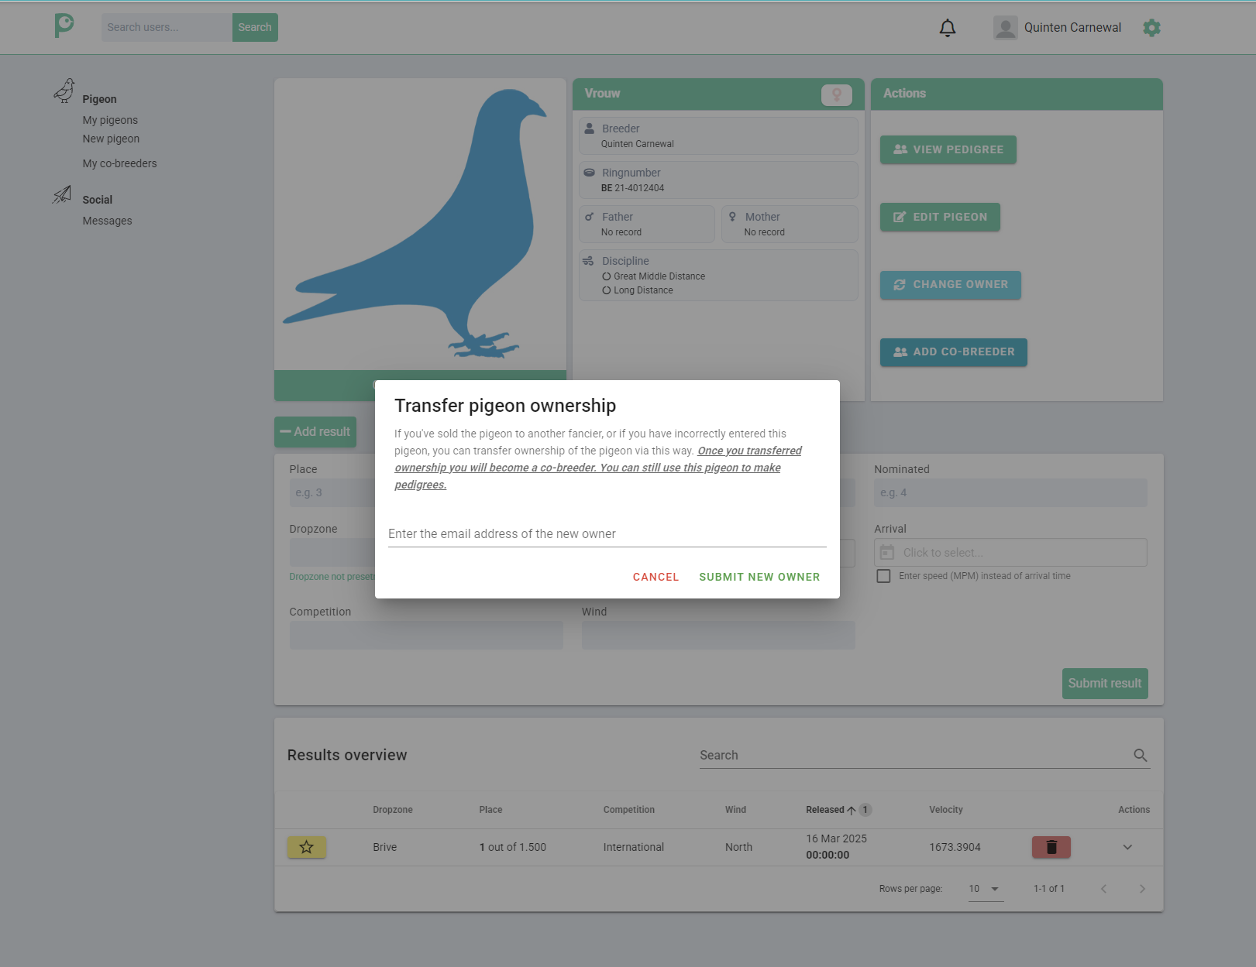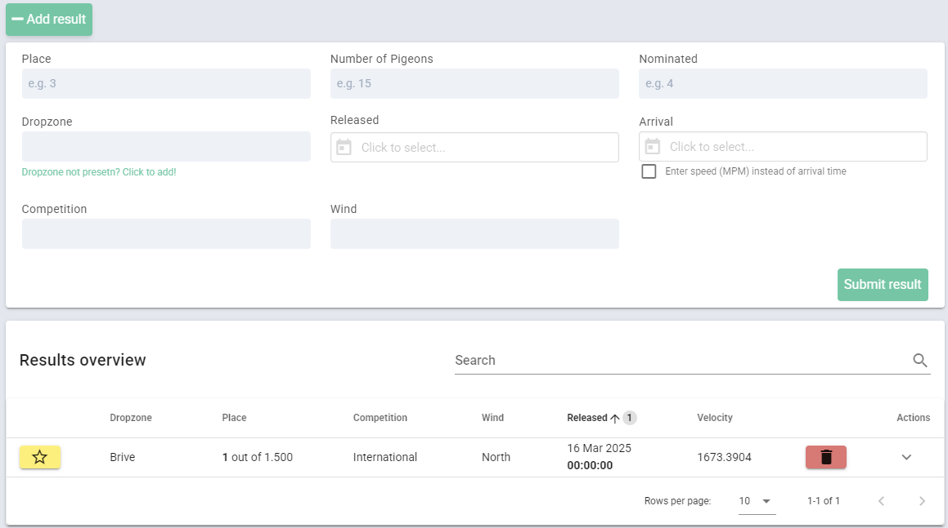

7. **Breeding - Pairing**

* When you breed birds then just pair the parents and the system will automatically merge their pedigrees to prepare them for the juveniles when born, no need to do anything more than name them and add their ring numbers
* This is just a select feature where you can select the parents of the new bird and creates the new pedigree automatically

8. **Information of pigeons (Optional)**

* **Health & Training Logs**: Keep records of medical history, diet, and training schedules.

Subscriptions features:

* Basis: (can change)
  + 30 Day Free Trial
  + Hobby breeders
  + Can add up to 100 different pigeons
  + 1 user
  + 250 pedigrees per year
  + OCR Technology
  + Bird pairing
* Standard:
  + 30 Day Free Trial
  + Professional breeders
  + Can add up to 300 different pigeons
  + 2 users
  + 300 pedigrees per year
  + OCR Technology
  + Bird pairing

### Race Results Management

* Ultimate:
  + 30 Day Free Trial
  + Professional breeders
  + Can add up to unlimited different pigeons
  + 5 users
  + unlimited pedigrees per year
  + OCR Technology
  + Bird pairing 

### Race Results Management